Sales Analytics Dashboard
Saudi Arabia Market Analysis
Year 2024 Performance Report
Prepared by: | Haya M.
Report Date: | February 7, 2026
Period Covered: | January 1, 2024 - December 31, 2024

Executive Summary
This comprehensive report analyzes the sales performance of our retail operations across 13 regions in Saudi Arabia for the fiscal year 2024. The dashboard provides critical insights into sales trends, customer behavior, profitability, and VAT compliance.

Key Performance Indicators
Metric | Value
Total Sales (Excl. VAT) | 1.89M SAR
Total Profit | 464.40K SAR
Profit Margin | 25%
Total Customers | 500
Average Order Value | 1.89K SAR
Total VAT Collected | 282.94K SAR

1. Sales Performance Analysis

1.1 Monthly Sales Trends
Sales performance showed significant variation throughout 2024, with December recording the highest sales at 179,687.37 SAR, representing a 40.25% increase compared to October, which had the lowest sales at 128,115.39 SAR.
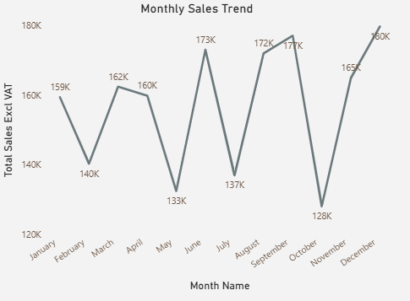
Key observations:
- Total sales across all 12 months ranged from 128,115.39 to 179,687.37 SAR
- December accounted for 9.53% of total annual sales
- Q4 showed strongest performance, indicating seasonal buying patterns

1.2 Sales by Channel
Our three sales channels (Retail Store, Online, and Direct Sales) contributed to the overall revenue, with Retail Store leading at 0.68M SAR, followed by Online (0.64M SAR) and Direct Sales (0.57M SAR).
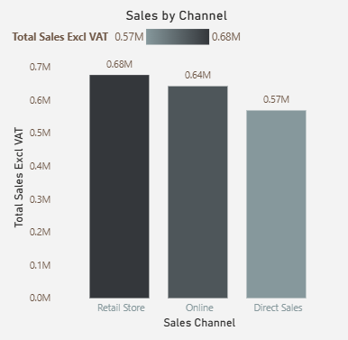

1.3 Top Performing Products
Product performance analysis reveals that External Hard Drives, Printers, and Smartphones lead the category, accounting for a significant portion of total sales.
Top 10 Products by Sales - Horizontal chart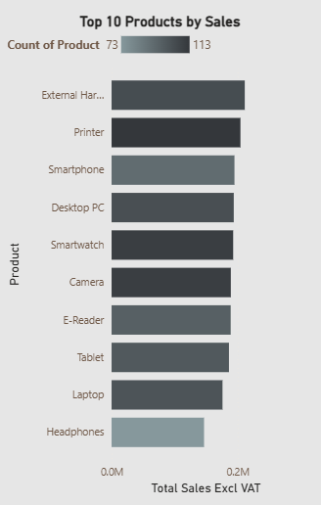

2. Customer Analysis

2.1 Customer Demographics

"Our customer analysis indicates an Average Spend per Customer of 3.77K SAR, providing a realistic baseline for customer value. This metric, combined with an average of 2 orders per customer, highlights a consistent purchasing pattern that drives our 1.89M annual revenue."
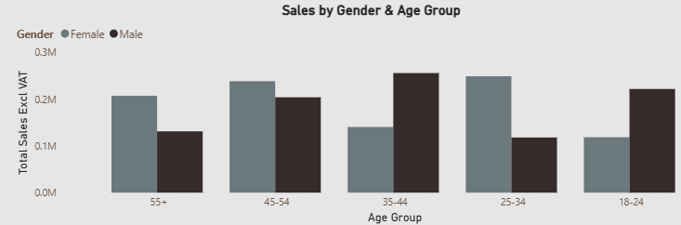Sales by Gender & Age Group - Stacked bar chart]
Key findings:
- Age group 35-44 shows the highest spending levels
- Gender distribution is fairly balanced across all age groups
- Female customers in the 35-44 age bracket represent the highest-value segment

2.2 Channel Performance
Analysis of Average Order Value (AOV) across sales channels reveals that the Online channel delivers the highest AOV at 1.95K SAR (34.57%), followed by Retail Store at 1.79K SAR (31.63%) and Direct Sales at 1.91K SAR (33.8%).
Average Order Value by Sales Channel - Donut chart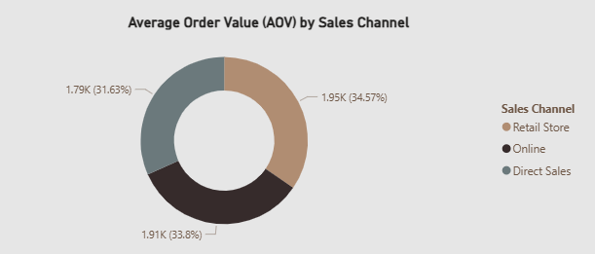

3. Profitability Analysis

3.1 Product Profitability
With a total profit of 464.40K SAR and an overall profit margin of 25%, our product portfolio demonstrates healthy profitability. The average unit cost stands at 290.24 SAR, with Printer emerging as the top profit-generating product.
Total Profit by Product - Horizontal bar chart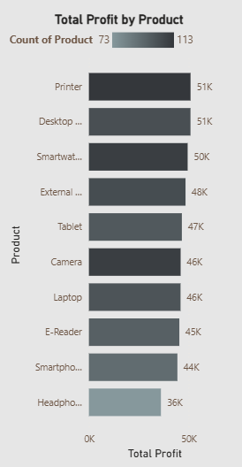

3.2 Profit Margin by Product
Profit margins across products remain relatively consistent, ranging from 23% to 26%, indicating effective pricing strategies and cost management across the product portfolio.
Profit Margin % by Product - Horizontal bar chart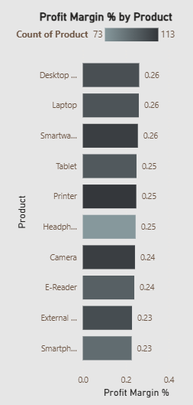

3.3 Regional Profitability
Regional profit margin analysis shows consistent performance across all 13 Saudi Arabian regions, with margins ranging from 23% to 28%. This uniformity suggests standardized pricing and cost structures across geographical market
Profit Margin % by Region - Vertical bar chart
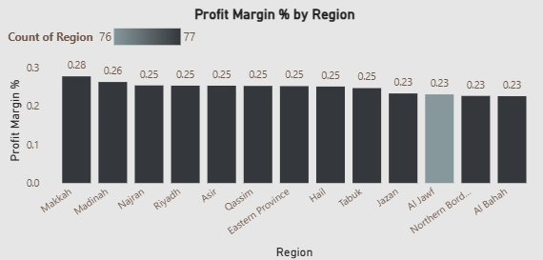

4. VAT & Time Analysis

4.1 VAT Compliance
The business maintains a 100% VAT compliance rate, with total VAT collected amounting to 282.94K SAR. The 15% VAT rate has been consistently applied across all transactions, ensuring full regulatory compliance with Saudi Arabian tax authorities.
VAT Collected by Month 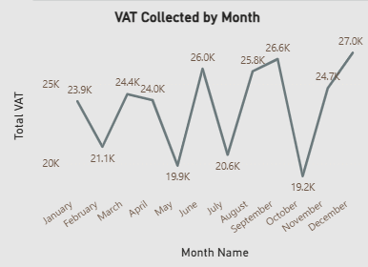

4.2 Temporal Sales Patterns
Sales data reveals distinct temporal patterns, with Tuesday identified as the peak sales day. The weekday-to-weekend sales ratio of 2.43 indicates that weekday sales are 143% higher than weekend sales, suggesting a B2B-oriented customer base or work-related purchasing behavior.
Sales by Day of Week
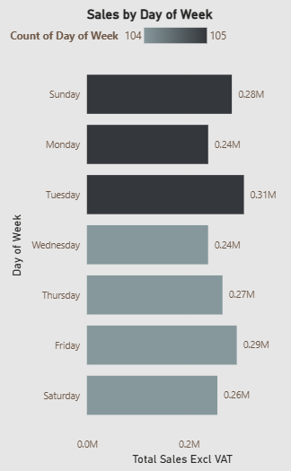
Weekend vs Weekday Sales
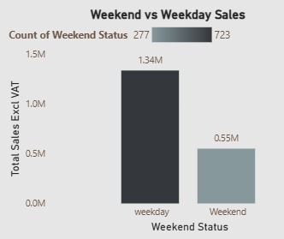

5. Conclusions & Recommendations

5.1 Key Findings
- Strong Financial Performance: Total sales of 1.89M SAR with a healthy 25% profit margin demonstrates robust business performance.
- Seasonal Variations: Q4 performance significantly outpaces other quarters, with December being the strongest month.
- Customer Loyalty: Average of 2 orders per customer indicates strong repeat business and customer satisfaction.
- Channel Diversity: Balanced performance across all three sales channels provides risk mitigation and growth opportunities.
- Full VAT Compliance: 100% compliance rate ensures regulatory adherence and eliminates tax-related risks.

5.2 Strategic Recommendations
- Capitalize on Q4 Momentum: Develop targeted marketing campaigns and inventory strategies to maximize Q4 opportunities.
- Address October Slowdown: Investigate factors contributing to October's underperformance and implement promotional strategies.
- Enhance Online Channel: Given the highest AOV in the online channel, invest in digital marketing and e-commerce capabilities.
- Target 35-44 Age Group: Create tailored products and marketing messages for this high-value demographic segment.
- Weekend Activation: Develop weekend-specific promotions to boost sales during typically lower-performing periods.
- Product Portfolio Optimization: Focus on top-performing products (External Hard Drives, Printers, Smartphones) while evaluating underperformers.
- Regional Expansion: Leverage consistent regional profitability to expand operations in underserved regions.

5.3 Next Steps
- Implement multi-year data collection to enable Year-over-Year analysis
- Develop customer segmentation strategies based on CLV and purchase frequency
- Create quarterly performance reviews to track progress against recommendations
- Establish KPI targets for 2025 based on 2024 baseline performance

Appendix

A. Data Sources
- Sales transaction data: January 1 - December 31, 2024
- Customer demographics database
- Product catalog and pricing information
- Regional sales records from 13 Saudi Arabian regions

B. Methodology
- Data visualization tool: Microsoft Power BI
- Analysis period: Full fiscal year 2024
- Currency: Saudi Arabian Riyal (SAR)
- VAT rate: 15% (as per Saudi Arabian regulations)

C. Glossary
Term | Definition
AOV | Average Order Value - The average amount spent per transaction
CLV | Customer Lifetime Value - Total revenue expected from a customer over their relationship with the business
VAT | Value Added Tax - Consumption tax levied at 15% in Saudi Arabia
KPI | Key Performance Indicator - Measurable value demonstrating business effectiveness

--- End of Report ---

